VPN PEERING

CREATE A VIRTUAL NETWORK
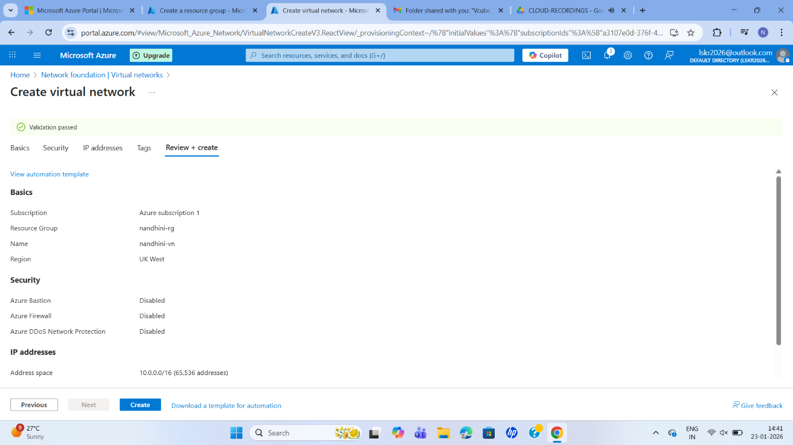
CREATE A VIRTUAL MACHINE
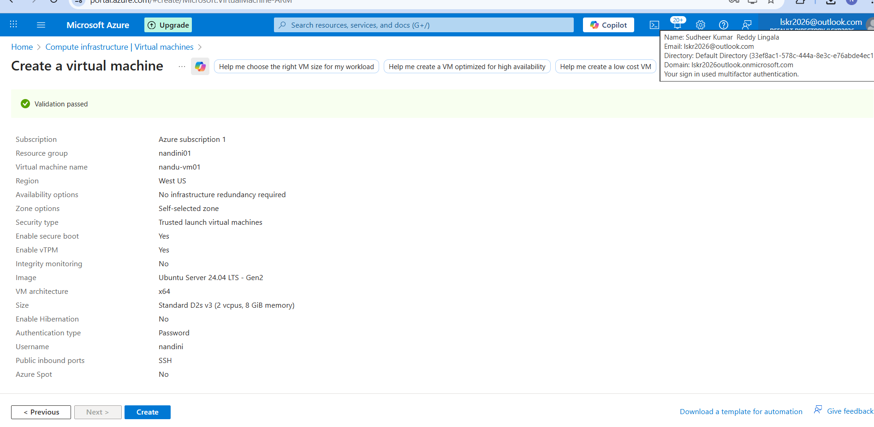
CONNECT BY USING PING COMMAND
VM01 PING PVT IP OF VM02
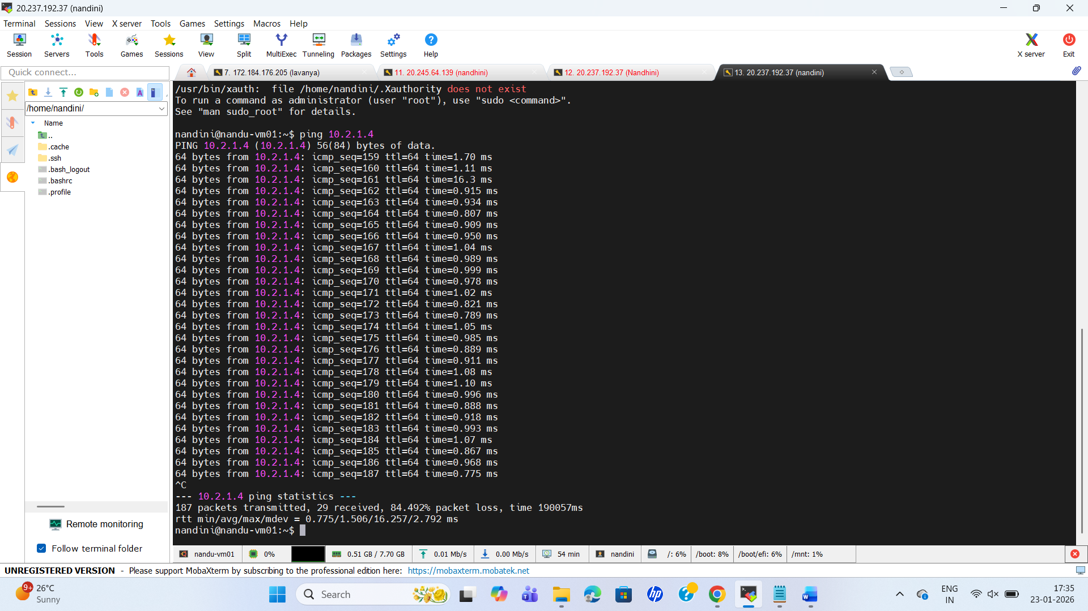
CREATE AN ANOTHER VIRTUAL NETWORK
OTHER REGION



